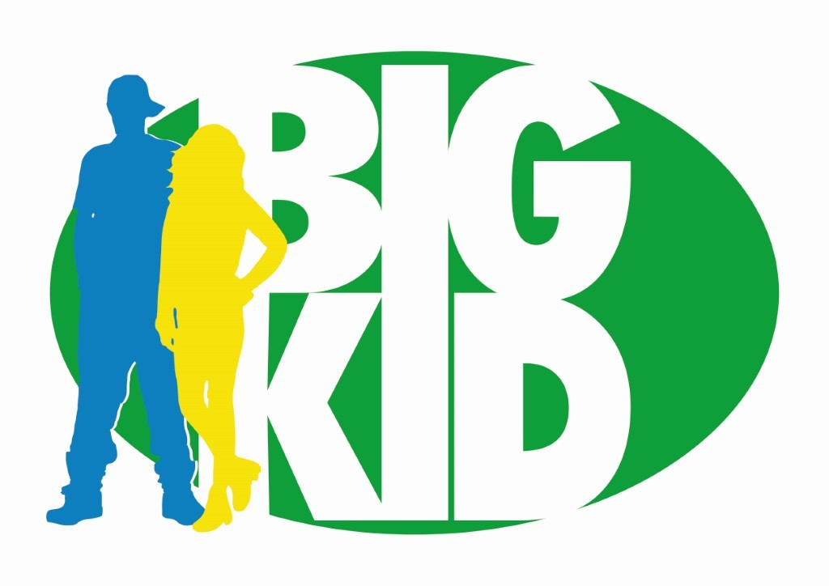

**Health and Wellbeing Coordinator**

BIGKID is looking for a dynamic and engaging health and wellbeing practitionerto join its dynamic team of youth workers in setting up an innovative, youth led emotional health and wellbeing service for our young people. We are looking for someone who is passionate about supporting young people and building their resilience. Above all, we want someone with the biggest **heart for the youth** of London!

|  |
| --- |
| **About Us** |
| BIGKID exists to equip young people at risk of social exclusion and youth violence to take control of their lives, find, develop and act on their own potential. We believe that behind every kid is something BIG.  We firmly believe in supporting and cultivating our staff enabling them to work flexibly, be creative and develop new areas of interest. We believe that by investing in the interests and values of our team we can enhance the work we do together and the impact we have with our young people. The BIGKID team culture is at the core of our work, and we work hard to nurture the team.  BIGKID is a fast growing, multi-award winning, organisation with many exciting opportunities from cook-off events with Michel Roux Jnr, music projects with DJ Semtex, sailing in Suffolk, NFL and Nike collaborations to quiz nights, youth club and mentoring. We encourage our team to be involved across the organisation with whole team efforts enhancing our success. This role will enable you to have many new and exciting experiences in a team which will encourage you to try new things and make the job your own.  BIGKID is possibly the best organisation you will ever work for. The work environment is flexible, family orientated and buzzing with creativity. |
| **About the role** |
| This post offers a unique opportunity for a mental health practitioner to establish, grow and embed emotional health and wellbeing into our new BIGKID setting in Brixton/Herne Hill, creating a welcoming, safe and innovative space for our young people to explore their emotional health and wellbeing.  We are looking for University students on placement year who are currently studying:   1. Youth Studies 2. Youth, Society & Sustainable Futures 3. Sociology with Psychology 4. Psychology with Education 5. Social Sciences   Who are dynamic, self-starting superstars, to work with our Operations and Development team so that mental health is seen as part of the fabric of our work and helps to reduce the stigma by reaching out to our young people and community.  You’ll need to be an all-rounder and an excellent communicator able to build relationships with community members and organisations as well as handle your own admin. Communication skills are essential and a willingness to commit and get behind the BIGKID vision.  This role is ideal for someone who has a passion for the emotional health and wellbeing of young people and with the creativity and drive to establish a new service destined for great things!  No, it’s not for the faint hearted but we can promise you will be supported all the way and you will have the great satisfaction of seeing your hard work lift a community and change young lives. |

|  |
| --- |
| **Main Duties and Responsibilities** |
| The role of Health and Wellbeing Coordinator will help establish and deliver a range of universal and targeted interventions to build resilience early in life for the young people attending the youth centre such as:   * One to one work * Refresher training of BIGKID Staff * Group Work   All of these support children and young people’s ability to engage in school, community and family life and also support the mental health of all at BIGKID.  You will have experience in health and wellbeing with a good knowledge of the youth environment. Most important of all is your approach; we are an exciting, dynamic organisation doing amazing work so we're looking for people with the enthusiasm and commitment to match our own.   1. Work with the DSLs (Designated Safeguarding Leads) and Head of Operations, ensuring mental health and wellbeing sessions are consistently promoted and delivered across BIGKID. 2. Assist with developing the confidence of our Young People, providing coping mechanisms with their studies and everyday life. 3. Contribute to the success of BIGKIDs strategy for mental health, well-being and personal development in order to meet KPIs. 4. Act as a key contact for our Young People, providing brief interventions and support to enable them to improve outcomes and build coping strategies as appropriate. 5. Develop and maintain effective partnerships working with local mental health, wellbeing, referral services, early intervention teams and other community partners to ensure timely and effective support, signposting, referrals, and intervention that lead to successful outcomes for our Young People. 6. Plan for and facilitate the active promotion of BIGKIDs mental health and wellbeing related policies, procedures and systems, alongside the DSLs and Head of Operations 7. Support the DSLs, HOO and Programme Managers to co-ordinate mental health and wellbeing session rooms, enabling our Young People to have appropriate spaces to better understand and improve their mental / emotional wellbeing 8. Produce and utilise mental health and wellbeing reports to monitor (and refer where necessary) on issues, ensuring BIGKID are able to tailor its wellbeing delivery and improvement 9. Undertake regular professional development to ensure mental health and wellbeing practices are relevant and BIGKID is equipped to address the needs of our Young People. 10. This role also includes helping to facilitate the Breaking Barriers sessions and providing key insight into how we can improve these sessions. |

**Essentials:**

* Experience of engagement with children and young people
* Understanding of Safeguarding within Youth Work and how this influences our work
* An understanding of potential barriers to mental health and wellbeing amongst Young People, alongside current, relevant mental health and wellbeing practices
* Experience of working with external agencies to build and maintain effective partnership working
* Knowledge and understanding of mental health, wellbeing and coping strategies
* Experience of providing brief interventions and support for Young People

|  |
| --- |
| **You should apply for this job because** |
| * BIGKID is an effective and fast-growing organisation * The work is exciting * You can make the role your own * You will be part of a fabulous team * You will be impacting the lives of hundreds (maybe thousands) of young people * You can bring your ideas to the table and see them through to fruition |

|  |
| --- |
| **Salary and Benefits** |
| * £25,000-28,000 per annum (pro rata) * Full/part time * Fixed term September 2025 – August 2026 * Travel/mileage within London * Flexible working * 28 days holiday pro rata |

**Application Process**

|  |  |  |
| --- | --- | --- |
| Stage |  | Dates |
| 1 | Send a current CV to Unika@bigkidfoundation.org | 20th June 2025 |
| 2 | * Interview at BIGKID office/over Zoom * Approx 1 hours in total | 30th June – 4th July 2025 |
| 3 | A short interview with our young people at the BIGKID youth club (online option if needed). Approx 30mins | 7th – 11th July 2025 |
| 4 | An interview with our CEO, Director and trustee. | 14th – 18th July 2025 |
| 5 | Notify successful applicants | 21st July 2025 |
| 6 | Start date | September 2025 |

BIGKID Foundation is committed to safeguarding and promoting the welfare of our children and young people. As part of our safeguarding commitment, appointment to any post is subject to receipt of satisfactory references and a satisfactory [Enhanced Disclosure and Barring Service (DBS)](https://www.gov.uk/dbs-check-applicant-criminal-record) check as well as evidence of the right to live and work in the United Kingdom. The charity uses preferred agencies and, in line with our safeguarding commitment, is unable to work with any agencies without prior agreement.